Competitive Shooters of Lake Norman USPSA October 16th, 2025
COURSE DESIGNER: Ike Starnes
START POSITION: See written stage briefings.

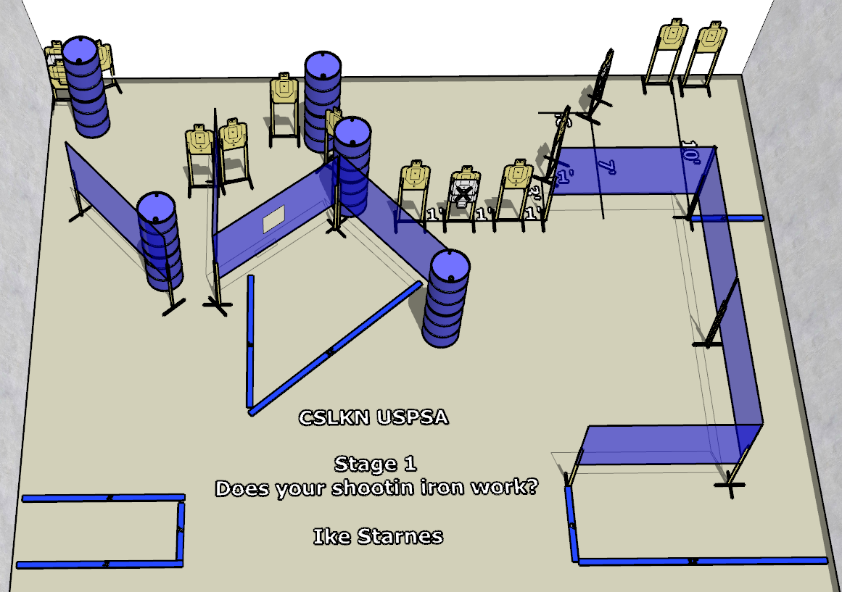

Written Stage Briefing:

Stage 1 - Does Your Shootin Iron Work? - is a 28-round, 140 point, Comstock Course. There are 14 cardboard targets and some no shoots. The best 2 hits per cardboard target will be scored.
Handgun start position Anywhere. The handgun is loaded and holstered.
PCC start position Anywhere. PCC is loaded with stock touching belt.
On the audible start signal, engage targets from within the shooting area.

